The Lord’s Day - May 31, 2026
“Then when Judas, His betrayer, saw that Jesus was condemned, he changed his mind and brought back the thirty pieces of silver to the chief priests and the elders.”
Matthew 27:3 (ESV)

Sunday School 9:00 AM

Morning Worship Service 10:15 AM
Welcome & Announcements

Quieting our Hearts & Offering - “Turn Your Eyes Upon Jesus”
Lori Nocella

Hymn #497 “I Will Praise Him”

Hymn #235 “Take the Name of Jesus with You”

Hymn #527 “I Know Whom I Have Believed” (Vrs. 1, 2, 3)

(Children’s Church dismissed - 4 yr. old - 3rd grade)

Scripture Reading & Prayer - Matthew 27:1-10 (Rick Westfall - ESV)

The Word - “Getting It Right After You’ve Gotten It All Wrong”
Larry Nocella

Hymn #509 “He Lifted Me” (Vrs. 1, 2, 4)

Postlude Lori Nocella

Evening Worship Service 6:00 PM

Announcements & Prayer

Prelude - “All Hail the Power of Jesus Name” Macey Reid

Hymn #502 “In My Heart There Rings a Melody”

The Word - “Why? What? - Habakkuk”
Will Hempel

Hymn #564 “Just a Closer Walk with Thee”

This Week at Camden

Wednesday - 7:00am-8:00pm Prayer Day at the Church
- 7:00pm Prayer Meeting

Thursday - 10:00am Prayer Meeting

Friday - 10:00am Ladies Missionary Prayer Team

Coming Events
June
7 - AM - Communion
9 - 7pm Deacons Meeting
11 - 7-8:30pm Choir Practice
13 - Men’s Breakfast & Bible 7:30am Coffee/Fellowship; 8:00am Breakfast is served
- 4pm-9pm Kaydia White Open House Her home 373 Cemetery Rd., Wellington
14 - 4pm-5:50pm VBS Kickoff Fellowship (Food provided: hot dogs, chips, ice
cream & a taste of Ireland. There will be games, activities and family fun.)
- 6pm-7pm VBS Kickoff Service
15-19 - Vacation Bible School
16 - Trustees Meeting

Nursery Ministry
May 31st
Sunday School: Karly Westfall & Liz Bond
AM Worship: Ashley Jordan & Lauren Rupe
PM Worship: Darcy Klier & Sally Pabst
June 7th
Sunday School: Joyce Harbaugh & Emily Klier
AM Worship: Sarah Williams & Sophia Klier
PM Worship: Debbie Hempel & Kim Polcyn

Children’s Church
(4 yr. old - 3rd grade)
May 31st - Helper: Rowan White
June 7th - Helper: Emrie White

General Giving - May 24, 2026 - 5,254.00
Weekly 2026 General Giving Budget - $10,557.69
Average Weekly General Giving through April 2026 - $9,951.47


Scan QR code to sign up for events and to give online.

NOTES

1) Help us celebrate & honor our country’s 250th Birthday! If you
are 6 yrs. old thru high school, Robin Aston (robinaston83@gmail.com)
invites you to sing in a children’s choir on Sunday, July 5th. Please
email Robin if you’d like a copy the songs you’ll be singing. Here
are the practice dates/times/place: In the choir room after the AM
Worship Service on Sundays June 7th, 14th, 21st, 28th and July 5th
before the AM Worship Service.

2) Baby Bottle Blessings Campaign - It runs from Mother’s Day thru
Father’s Day. Pick-up a baby bottle from the basket in the foyer, fill
it with change, cash or check (Made out to “Cornerstone”). Return the bottle
before Father’s Day. Questions see/call Theresa Thrasher
443.223.1000. Thank you!

Our Worship Services
Sunday School 9:00am
AM Worship Service 10:15am
PM Worship Service 6:00pm
Wednesday - Prayer Meeting 7:00pm
Thursday - Morning Prayer Meeting 10:00am

Welcome Visitors
There are Communication Cards in the back of the hymnal for visitors & prayer requests. Please fill it out and place in basket on the shelf
along the back wall. Thank you!


Sunday, May 31st - Faith Baptist
Church, Elida

Where’s
William???

Bill Kopas, State Representative of
Ohio Association of Regular Baptist Churches

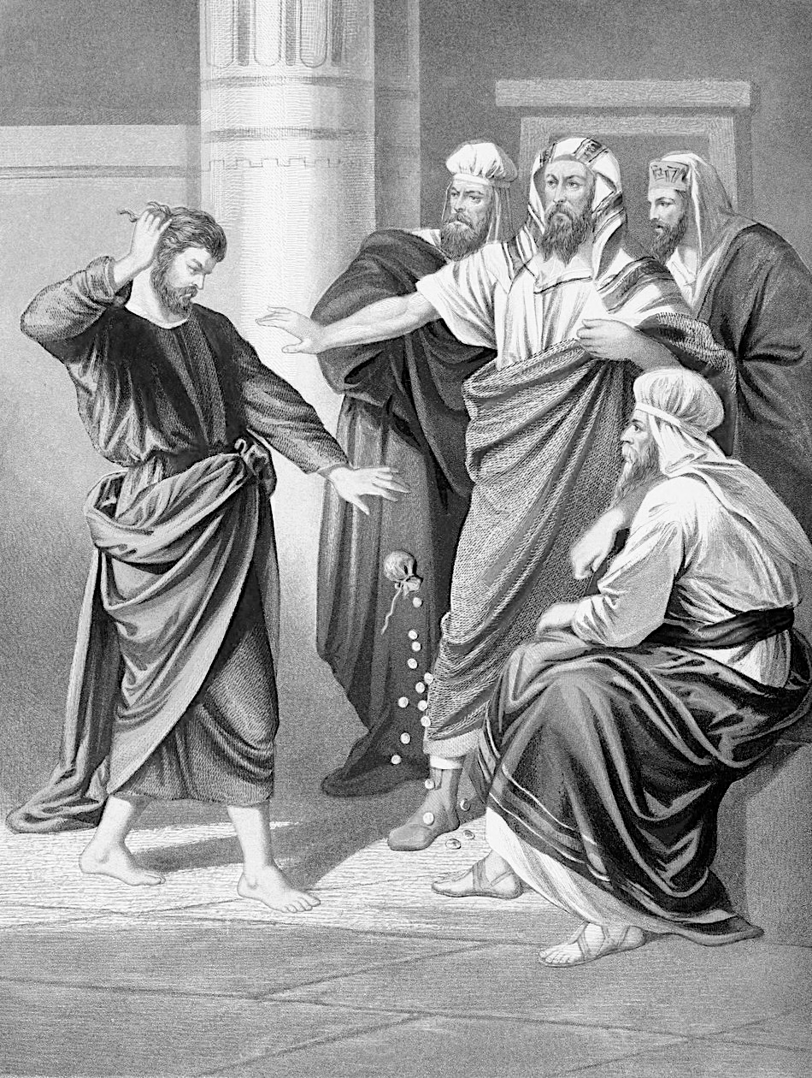

Camden Baptist Church

17901 State Route 511
Wellington, OH 44090
(440) 774-5732
Email: camdenbaptist@gmail.com
Web: www.camdenbaptist.com
Facebook: facebook.com/camdenbaptistchurchoh/

Larry Nocella - Pastor

